Build A Mobile App

|  |  |
| --- | --- |
| Team ID | PNT2022TMID45278 |
| Project Name | Real-time river water quality monitoring and control system |

Configure The Application To Receive The Data From Cloud

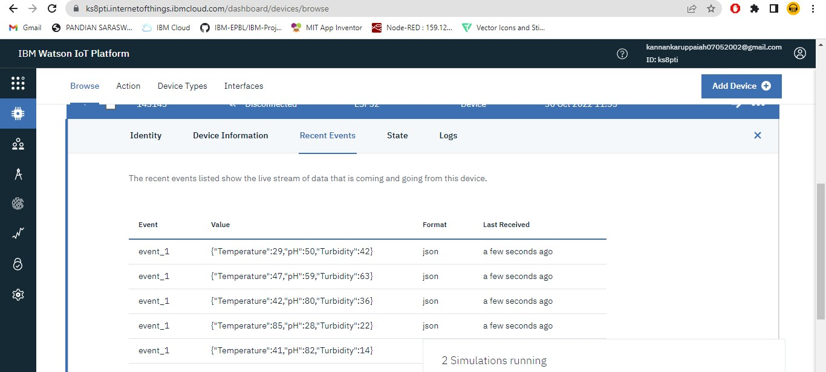Data Is Sending From IBM IOT Watson:

Initial Stage Of App:

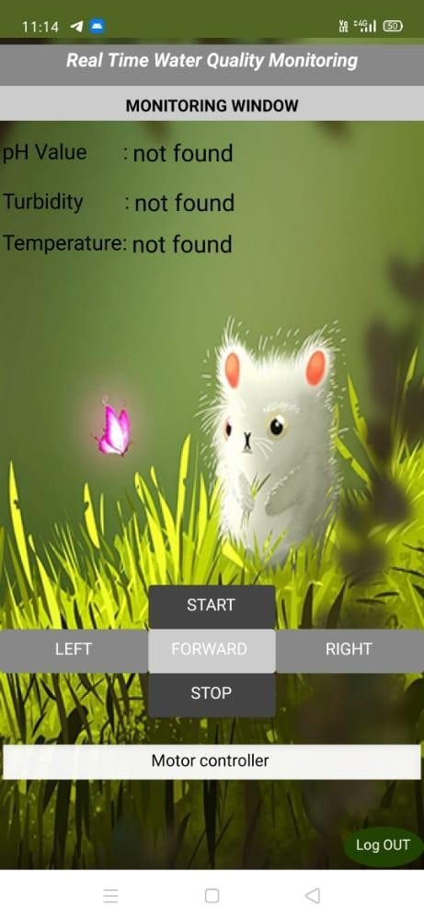

Now Data Is Collected From The IBM:

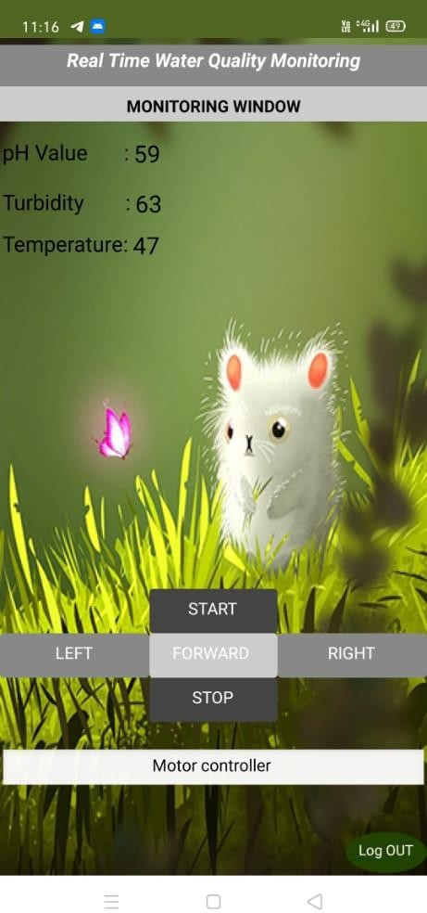

Take Another One Data From IBM:

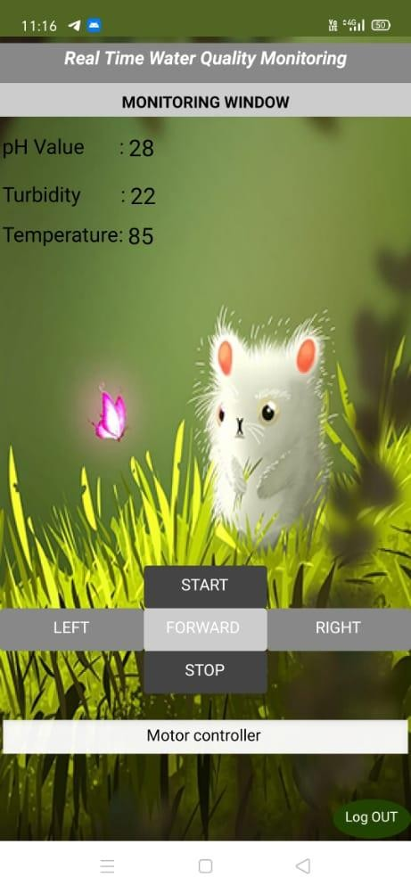

It is Backend of Our App:

